MSI hazard identification checklist – instructions and template
Use this checklist as a starting point for identifying and controlling for MSI hazards in your formal hazard assessment. This checklist does not replace the hazard assessment documentation required by the OHS Code Section 7.
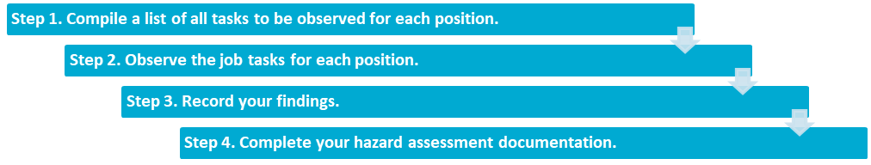

Step 1. Compile a list of all tasks to be observed for each position.
You may have to adapt or expand this checklist to meet the unique context of your work site(s). For jobs with a lot of variability, complete this checklist for each of the different tasks within the job.
For highly repetitive jobs, completing this checklist once for that job may be sufficient. Start with a blank checklist for each different task to be observed.

Step 2. Observe the job tasks for each position.
Record the task name, location, date and time observations were completed, and who completed the observations. Observe different workers performing the same task if possible. This will give you a better sense of the overall postural demands and different strategies different workers may use.
Have conversations with the workers to get a better sense of the amount of time the tasks take.
- Asking the workers about their job task will help to make sure you don’t miss any critical components.
- Workers may be able to highlight specific challenges they encounter when doing certain job tasks, and may also point out or suggest effective controls.

Step 3. Record your findings.
Record your observations. Use the notes section to record identified MSI hazards and note if particular tasks have more than one hazard present. The presence of multiple hazards increases the risk for an MSI to occur.
This checklist can also help you decide if the lifting assessment tool, found in Ergonomics in the workplace: Identifying and controlling manual handling hazards, needs to be used to determine safe lifting limits for the observed tasks.

Step 4. Complete your hazard assessment documentation.
Incorporate the identified MSI hazards into your formal hazard assessment report and include the methods used to eliminate or control the hazards identified. Read the following bulletins for guidance on selecting controls:
- Hazard Assessment and Control: a handbook for Alberta employers and workers
- Ergonomics in the workplace: Identifying and controlling manual handling hazards

MSI hazard identification checklist
Task name:
Company name: |  |  |  |  |  |  | Job title:
Location: |  |  |  |  |  |  | Department:
Evaluated by: |  |  |  |  |  |  | Date and time:
Awkward postures
Neck
Select the appropriate box(es) below if workers are in one or a combination of these postures for two or more hours a day. |  |  |  |  |  |  |  | Notes:
neck is bent more than 30 degrees sideways |  | neck is bent more than 30 degrees forward or backward |  |  |  | neck is twisted to either side |  | Notes:
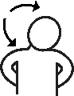 |  | 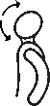 |  |  |  | 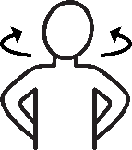 |  | Notes:
☐ |  | ☐ |  |  |  | ☐ |  | Notes:
Shoulders
Select the appropriate box(es) below if workers are in one or a combination of these postures for two or more hours a day. |  |  |  |  |  |  |  | Notes:
reaching with the hand(s) above head |  |  |  | reaching forward or to the side with the elbow(s) above shoulder |  |  |  | Notes:
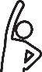 |  |  |  |  |  |  |  | Notes:
☐ |  |  |  | ☐ |  |  |  | Notes:
Hands/ wrists/ forearms
Select the appropriate box(es) below if workers are in one or a combination of these postures for two or more hours a day. |  |  |  |  |  |  |  | Notes:
wrists bent more than 15 degrees in any direction |  |  | hold an object weighing 1 kg (2 lbs) or more with a pinch grip |  | hold an object weighing 4.5 kg (10 lbs) or more with a power grip |  |  | Notes:
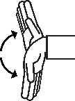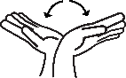 |  |  | 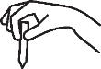 |  |  |  |  | Notes:
☐ |  |  | ☐ |  | ☐ |  |  | Notes:

Back
Select the appropriate box(es) below if workers are in one or a combination of these postures for two or more hours a day. |  |  |  |  |  |  |  |  |  |  | Notes:
forward bending (>30°) |  | backward bending(>30°) |  | side bending (>30°) |  |  |  |  | twisting
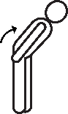 |  | 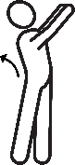 |  | 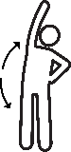 |  |  |  |  | 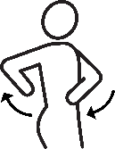
☐ |  | ☐ |  | ☐ |  |  |  |  | ☐
Static postures
Select the appropriate box(es) if a worker is: |  |  |  |  |  |  |  |  |  |  |  | Notes:
sitting for extended periods without standing or walking |  |  |  |  |  |  | standing for extended periods without sitting or walking |  |  |  |  | Notes:
☐ |  |  |  |  |  |  | ☐ |  |  |  |  | Notes:
Other postures
Select the appropriate box(es) below if workers are in one or a combination of these postures for two or more hours total per day. |  |  |  |  |  |  |  |  |  |  | Notes:
squatting |  |  |  |  | kneeling
 |  |  |  |  | 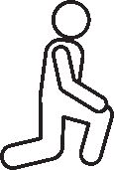
☐ |  |  |  |  | ☐
Repetition
Repetition
Select any body areas that are performing the same steady motion or an exertion is repeated with little variation for two or more hours a day (four or more hours a day for typing) |  |  |  |  |  |  |  |  |  |  | Notes:
head/ neck | shoulders |  | elbows |  |  | hands/ wrists |  | back |  | legs/ feet
☐ | ☐ |  | ☐ |  |  | ☐ |  | ☐ |  | ☐

Forceful exertions
For any lifting required in this task, consider the following points. If you select yes for any of the listed items, please continue on to the Lifting assessment tool found in Ergonomics in the workplace: Identifying and controlling manual handling hazards. |  |  |  |  | Yes | No
Worker(s) must lift a load that is heavy and/or bulky. |  |  |  |  | ☐ | ☐
Worker(s) are required to lift objects without evenly distributed handholds or handles. |  |  |  |  | ☐ | ☐
The size of the load, or the design of the lift, requires the worker(s) to outstretch their arms to grasp the load. |  |  |  |  | ☐ | ☐
The lifting of the load requires handling of the load below knee height and/or above shoulder height at any point during the lift. |  |  |  |  | ☐ | ☐
The lifting of the load requires twisting of the back and/or trunk. |  |  |  |  | ☐ | ☐
Contact stress and impact stress
Select the appropriate boxes if a worker is exposed to the following hazards during the task. |  |  |  | Notes:
equipment edges or ground place pressure on a small area of the body (hands, forearms, trunk, legs) | tool handles dig into the body (hand, or other body part) |  | using the hand or knee as a hammer
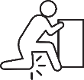 |  |  | 
☐ | ☐ |  | ☐
Vibration
Select the appropriate boxes if workers are exposed to vibration. |  |  |  | Notes:
using vibrating tools | worker sitting on a vibrating surface |  | worker standing on a vibrating surface
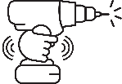 | 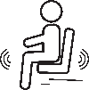 |  | 
☐ | ☐ |  | ☐
Other
Use this section to note any other MSI risk factors that have not been addressed. |  | Notes:
This checklist is adapted from the Centre of Research Expertise for the Prevention of Musculoskeletal Disorders¹ and the Washington State Department Labor & Industries².

