Lifting assessment tool
This is one example of a lifting assessment tool that can be used as a starting point in assessing if lifting activities are within recommended limits to reduce the risk of MSIs. Be advised this tool is a guide and workers’ individual factors must also be considered. This tool is only a guide. If you choose to use this tool, it is important and necessary that you customize it to meet the unique circumstances of your work, workers, and work site. Completing this tool alone will not necessarily put you in compliance with the legislation
If the job involves a number of lifts with different weights and/or different postures, use steps 1-6 to assess the heaviest object lifted and the most awkward part of the lift. In step 3, use the Frequency + Duration Adjustment for all of the lifting done in a typical workday.
Step 1  Determine the actual weight of the object that the worker lifts.  Actual Weight: |  | Step 3  Determine the Frequency + Duration Adjustment.  Find out how many times the worker lifts per minute and the total number of hours per day spent lifting. Use this information to look up the Frequency + Duration Adjustment value in the following table:  Note: For lifting performed less than once every five minutes, use 1.0.  Frequency + Duration Adjustment:
  How many lifts per minute? | For how many hours per day?
  How many lifts per minute? | 1h or less | 1h to 2 h | 2h or more
  1 lift every 2-5 min. | 1.0 | 1.0 | 0.85
  1 lift every min. | 0.95 | 0.95 | 0.70
  2-3 lifts every min. | 0.90 | 0.85 | 0.60
  4-5 lifts every min. | 0.85 | 0.70 | 0.50
  6-7 lifts every min. | 0.60 | 0.50 | 0.35
  8-9 lifts every min. | 0.40 | 0.30 | 0.15
  10+ lifts every min. | 0.20 | 0.10 | 0.05
Step 2
Determine the Unadjusted Weight Limit. Determine the most extreme hand position during the lift/lower task. Mark that spot on the diagram below. The number in that box is the Unadjusted Weight Limit.
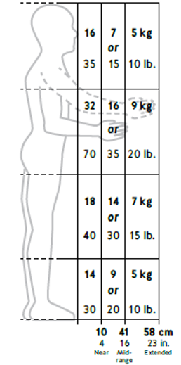
Unadjusted Weight Limit:
Step 4
Determine the Twisting Adjustment.
If the worker twists their back/body more than 45 degrees: | 0.85
No twisting or twisting less than 45 degrees: | 1.0
Twisting Adjustment:

Step 5
Calculate the Weight Limit. Multiply the Unadjusted Weight Limit (step 2) by the Frequency + Duration Adjustment (step 3) and the twisting adjustment (step 4) to get the Weight Limit.
Weight Limit
Step 4
=
x
x
Step 3
Step 2

Actual Weight Weight Limit
Step 6
Analysis. Compare the Actual Weight (step 1) to the Weight Limit (step 5). If the Actual Weight is greater than the Weight Limit there is an increased risk for MSI and controls should be put in place to eliminate or reduce the risk.
This tool is adapted from WorkSafeBC. For an online version visit their website.

