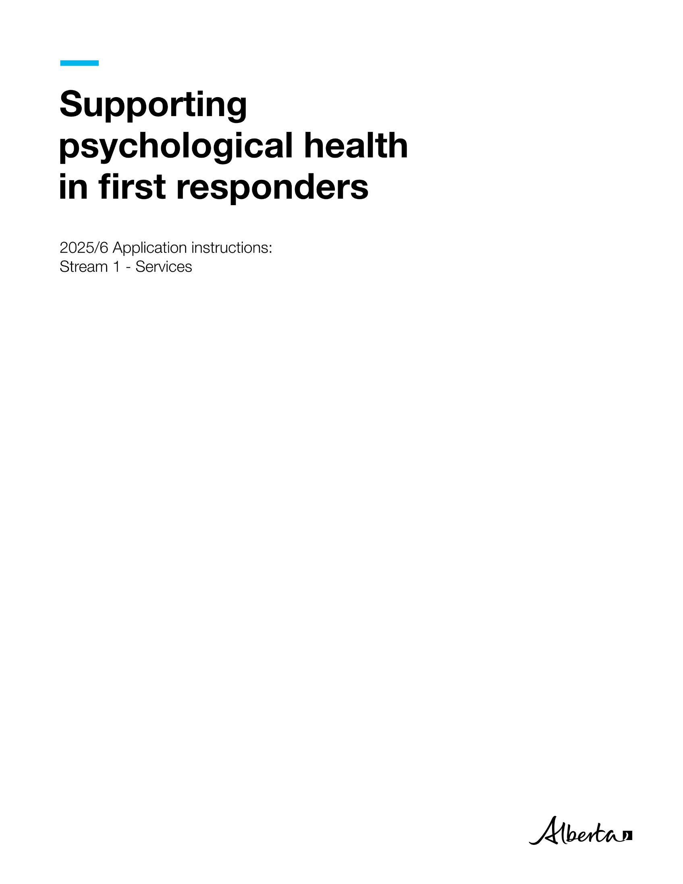



General information

The Supporting Psychological Health in First Responders (SPHIFR) grant program is a competitive grant funding program. It supplies funding to provide or improve services that support first responders or emergency workers living with or at risk for post-traumatic stress injuries (PTSI). For SPHIFR purposes, first responders and emergency workers are defined as workers who provide immediate assistance at emergency scenes. Emergencies are defined as serious, unexpected and often dangerous situations requiring immediate action.

The application submission deadline is **May 26, 2025, at 11:59 p.m. MDT**. Only applications that are complete and are received before this deadline will be eligible for funding.

The SPHIFR grant program has two streams:

* **Stream 1 (Services)** provides project-based grants to not-for-profit or public sector organizations. These projects must provide services that support Alberta first responders or emergency workers living with, or who are at risk of, PTSI.
* **Stream 2 (Applied Research)** provides grants for applied research to develop and evaluate effective programs and services to support Alberta first responders or emergency workers living with, or who are at risk of, PTSI. Examples of such programs and services include early intervention or resilience-building.

**The eligibility criteria and instructions in this document are only for Stream 1 (Services) applications.** If you want to apply for funding under Stream 2, see [Stream 2 (Applied Research) eligibility criteria and instructions](https://ohs-pubstore.labour.alberta.ca/grt002) on Alberta’s OHS Resource Portal. If you have questions about which stream is the best fit for your project, contact [SPHIFR@gov.ab.ca](mailto:SPHIFR@gov.ab.ca).

Applicants can seek SPHIFR grant funding for multiple projects in a funding year. Each project must be distinct and independent. Applicants must submit a separate and standalone application for each project.

You can submit this application for funding to continue a project that received SPHIFR funding in the past. You can also submit this application if you are hoping to apply for funding in subsequent years (for the same project or a different project). However, it is important to note that receiving SPHIFR funding in any given year neither implies nor guarantees you will receive funding in this or any future year.

Alberta Jobs, Economy, and Trade (“the Ministry”) will notify applicants about the outcome of their application in writing. Grant recipients will receive a grant agreement that includes the terms and conditions of the grant. You can see a sample agreement [here](https://ohs-pubstore.labour.alberta.ca/grt001-1). Projects cannot start before both parties (the grant recipient and the Ministry) sign the grant agreement. Grant recipients must complete projects within 12 months of the date the grant agreement is signed by both parties.

Evaluation

The Ministry evaluates the information provided in each SPHIFR application individually. If applicable, the Ministry will also consider publicly available information (e.g. websites) and an applicant’s previous grant performance with the Ministry. The Ministry may not issue a grant to applicants who have not met the terms and conditions of previous Ministry grants.

If the applicant has identified a project partner, the Ministry may consider the partner’s publicly available information and previous grant performance with the Ministry.

The Ministry will give preference to projects that incorporate considerations of sex, gender, sexual orientation, ethnicity, indigenous perspectives, geography, faith, income, gender identity and gender expression.

Stream 1 (Services) eligibility criteria

|  |  |  |
| --- | --- | --- |
| **Criteria** | **Eligible** | **Not Eligible** |
| **Applicant** | **Must:**  Be a non-profit or public sector organization (i.e. a non-profit company, society, municipality, school board, health authority, public post-secondary institution or a similar extra-provincial entity).   * Have a mandate to provide, or demonstrated history of providing, a service clearly related to PTSI, first responders or emergency workers.   Operate within Alberta and already be delivering services. | **Must not be:**   * An individual. * A for-profit organization. * A provincial or federal government, agency, board or commission.   An organization applying on behalf of another organization. |
| **Proposed project** | **Must be:**  Dedicated to providing services that support Albertan first responders and/or emergency workers living with, or at risk of developing, PTSI.  Completed in 12 months.  Based on published research or formal evaluation evidence that supports its effectiveness at impacting PTSI. | **Must not:**   * Be a project that is already in progress or has been completed. * Provide one-on-one services to a specific individual.   Focus on general mental health or wellbeing without a clear focus on PTSI.  Be solely for military personnel, RCMP or veterans.   * Focus on capitalization of business enterprises (e.g. for-profit activities and product development).   Duplicate or replace programs or services already provided by the Government of Alberta.   * Focus on lobbying activities.   Be directed towards a provincial or federal agency, board, or commission as the primary participant, sole audience or direct beneficiary of the project deliverables. |
| **Budget** | **Can fund:**   * Consultants or contractors required for the project due to a specialized need or skill set. (Describe their role and skill set.) * Materials or equipment needed specifically for the project. * Travel and subsistence costs directly related to and necessary to carry out the activities under the project. **Note:** These costs must comply with the Government of Alberta’s [Travel, meal and hospitality expenses policy.](https://open.alberta.ca/publications/travel-meal-and-hospitality-expenses-policy-expenses-policy) * **Other** expenses directly related to the project, including:   + staff training costs;   + staff role, salary costs, and FTE amount; and   + any other required details to support the justification. | **Cannot fund:**  Conferences.   * Capital purchases that are global to the organization’s needs rather than specific to the program/project this application is for. * Business operational expenses. These include, but are not limited to: * Purchases of office equipment, office supplies, furniture, electronics, personal protective equipment. * Regular maintenance upgrades to existing websites (e.g. simplifying language or easing navigation of website). * Office software, applications, or licences (e.g. Microsoft Office, Adobe Creative Suite). * Telephone or voicemail connection and rental costs, etc. * Compensation expenses related to discretionary severance and separation packages. * Travel and subsistence costs related to commuting between a residence and place of employment. * Insurance costs (e.g. for equipment, facilities, etc.). * Costs for construction or renovation of organization or project facilities. * Expenses where a personal benefit could be derived are ineligible. * Education or training unrelated to the project. |

How to fill out the application form

Begin your application by downloading and completing the [grant application form](https://cfr.forms.gov.ab.ca/Form/OHSP12387). The application form is a dynamic form; fields will appear or disappear depending on your selections.

As you fill out the form, you can click the **Save** button to save your progress, or the **Print** button if you would like to print out the form. Clicking the **Reset** button will reset the form and erase all data that has been entered thus far; be careful not to inadvertently click this button as you proceed through the form.

The application form’s fields will display word limits, which are also stated in the instructions below. The Ministry will not consider any information that exceeds a designated word limit.

The Ministry may quote portions of successful applications in public communications, including on the [SPHIFR grant program](https://www.alberta.ca/first-responders-mental-health-grants.aspx#jumplinks-5) website. Do not include confidential information in the form.

Descriptions of the application form’s sections and fields, and the information that must be provided in them, are as follows:

SPHIFR stream selection

When you first open the grant [application form](https://cfr.forms.gov.ab.ca/Form/OHSP12387), you will need to select the stream for which you are applying: **Stream 1 (Services)** or **Stream 2 (Applied Research)**. The rest of the application form will appear, with fields based on the stream you selected.

Project Title

Provide a short descriptive title for the project. The Ministry will use this title in future communications.

1. Applicant Information

The applicant is the organization that will be accountable for all project deliverables and reporting requirements, and will lead project planning, scope and timelines. The Ministry will disburse funds for successful applications to the applicant.

The applicant’s contact person will receive all project correspondence and notifications from the Ministry. Notify [SPHIFR@gov.ab.ca](mailto:SPHIFR@gov.ab.ca) if the contact information changes after you submit the application.

## Organization Mandate

The organizational mandate introduces the applicant. The mandate should connect to the proposed project and demonstrate how the project is relevant to your organization.

**Word limit: 100**

2. Partner Information

A partner is an organization that is in a formal working relationship with the applicant and will contribute meaningfully to the project. The partner role can include participating in project planning, supporting achievement of deliverables or providing subject matter expertise. The project objectives should align with the partner’s organizational mandate.

SPHIFR funding cannot be used to compensate a partner for their execution of specific tasks or components of the project. A partner cannot profit from the completed project.

Although the partner will contribute meaningfully to the project, the applicant remains responsible and accountable for all project deliverables and reporting. **The applicant must confirm the partner’s participation before including them in the application.**

## Partner role in the project

Your partner must provide a letter on their organization’s letterhead. This letter must indicate their specific role in achieving the project deliverables. You must attach this letter to your application email. (See **Application Attachments**.)   
**Word limit: 150**3. Project Summary

## What is the project?

In five sentences or less, clearly describe the project. Include:

* what service will be offered,
* the audience who will attend or receive the services (e.g. specific group of workers, family members, front-line supervisors, etc.), and
* the project’s purpose or objectives.

Projects must provide services that support Alberta first responders or emergency health care workers living with or at risk of PTSI.

**Word limit: 300**

## How does this project provide services that support first responders or emergency workers who are living with or at risk of post traumatic stress injuries (PTSI)?

Provide details on how the service will be delivered and how the proposed project will reach the audience identified in the previous question. Describe the purpose or goal of reaching this audience.

Examples of service delivery include: in-person group or class setting, on-line resources, e-learning and training development.

**Word limit: 300**

## Does the proposed service consider ways to build capacity within first responders, emergency workers, or their supports to prevent PTSI or lessen the severity of PTSI in workers following traumatic incidents? Explain how.

Provide details on how the service will prepare first responders or emergency workers for traumatic events or prepare front-line supervisors and family members to support workers who experience traumatic events, in order to ultimately prevent or lessen the severity of PTSI among workers.

**Word limit: 300**

## What are the project limitations and risks?

Identify the potential limitations of or risks to successful completion of the project.

Examples include: Uncontrollable circumstances; participants’ work schedule or shift rotation; distance from participants to the program location.

Include potential solutions to mitigate the identified risks.

**Word limit: 300**

## Is there evidence that supports the effectiveness of the proposed project and its ability to prevent or treat PTSI?

Include any references to literature or past program evaluation that supports the effectiveness of the proposed project to prevent or treat PTSI.

**Word limit: 300**

## How will you evaluate the project?

Describe how you will know if the project has been successful. Include qualitative and quantitative indicators and/or measures where possible. Only include items that you can assess within the 12-month project term.

Examples include:

* Pre- and post-service surveys to understand participants’ perceived value of the service.
* Identified deliverables completed on time and within budget.
* Desired audience/participant numbers reached.

**Word limit: 300**

## Will there be a fee for access?

If a fee will be charged to access the service, provide an estimate of the amount. Describe the rationale for the fee and estimate what portion of the service the fee will cover.

**Word limit: 300**

## How is this project distinct from your regular business?

Describe how this project is different from your existing services and those of your partner (if applicable).

**Word limit: 300**

4. Audience Information

## What are the key details that describe your audience?

Identify who will attend or receive the service(s) resulting from the project. Provide specifics (e.g. location and demographic information, including the type of first responder or emergency worker if the audience includes front-line supervisors and/or families) and any selection parameters.

**Word limit: 300**

## Indicate the estimated audience size

Audience size is the approximate number of people who will be able to attend or receive the service(s) covered by the project. Consider factors such as the duration of the grant (12 months), the location, the venue capacity and availability of required resources in your estimate.

You can only enter your estimate as a number in this field. Provide a written rationale for the estimate in the next field.

## Provide the rationale for the estimate

Describe how you estimated the audience size.

**Word limit: 300**

## Specific to where the project will be implemented or delivered, what region is covered?

Select the area that best describes where your project will take place (i.e. where will the service(s) will be delivered).

5. Project Schedule

Use the provided table to describe major milestones, associated timeframes and deliverables. Milestones are tangible accomplishments that are significant to the project’s progress and success. Give timeframes in weeks or months relative to the start date of the project, not in absolute dates (e.g. “Week 5”, not “the first week of September”).

Ensure that the milestones include development, delivery, evaluation and any post-event/wrap-up tasks.

**Example:**

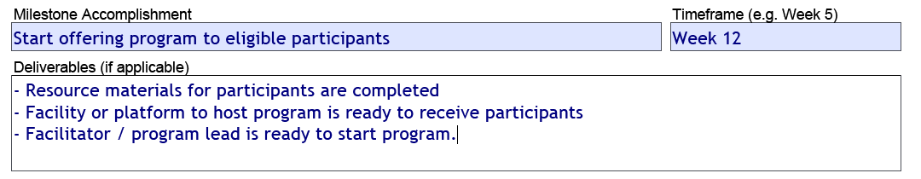

Use the **(+) button** at the bottom of the table to add additional milestones.

**Note**: Projects cannot start before both parties (the grant recipient and the Ministry) sign the grant agreement. Grant recipients must complete projects within 12 months of the date the grant agreement is signed.

6. Project Resources

## Resource

List one or more resources required for the project. Examples include consultants, contractors, equipment and software.

Indicate what resources the organization currently has, along with what resources the organization will need to procure for the project.

You must also indicate whether you have applied to another Government of Alberta ministry or program for this project.

## Additional funding sources

Identify other sources of funds or key resources that you have secured or requested for the project, such as other organizations supporting the project with financial or physical assets. Indicate the value amount of these resources. For each additional funding source, indicate whether the contribution is in cash or in-kind and indicate whether your organization has received the contribution.

**Word limit: 300**

7. Project Budget

Outline the budget items the SPHIFR grant will fund in the table. Explain how each item supports the project goal. **Note**: It is the responsibility of the applicant to ensure that receipt of this funding will not create a funding dependency. Receipt of funding does not imply or guarantee funding in any future year.

Eligible items include:

* **Consultants or contractors** required for the project due to a specialized need or skill set. (Describe their role and skill set.)
* **Materials** or equipment needed specifically for the project.
* **Travel** costs that do not exceed **10 per cent of the total budget** or **$5,000**, whichever is lower. (If additional travel funds are required, provide a justification for the additional funds.)
* **Other** expenses directly related to the project, including:
  + staff training costs;
  + staff role, salary costs, and FTE amount; and
  + any other required details to support the justification.

If you are not sure if a budget item is eligible, contact [SPHIFR@gov.ab.ca](mailto:SPHIFR@gov.ab.ca) before you submit the application.

The Total Amount Requested field will be automatically calculated based on the amounts you enter in the table.

**Example (details provided are for example purposes only):**

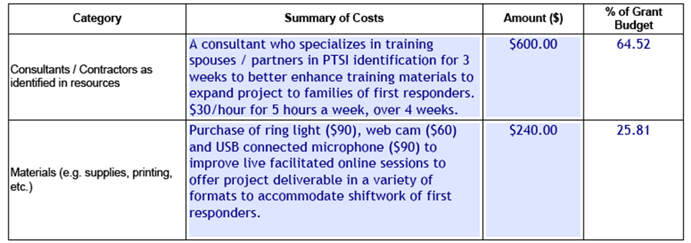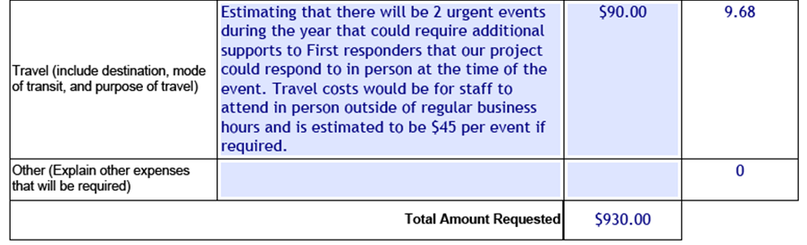

**Note:**

Non-public bodies that receive a grant between $100,000.01 and $250,000 must provide a **Review Engagement Report**.

* The Review Engagement Report must be prepared by a third-party Chartered Professional Accountant who is not associated with your organization.
* This report must have accompanying financial statements showing the grant income and expenditures (either as a separate statement or as a schedule attached to your organization’s overall unaudited financial statement) and the return of any unused funds, if applicable.
* The report must confirm that the funds were only used in accordance with the purpose of the grant.
* This report will be due 90 days after your organization’s fiscal year end.
* The cost of the Review Engagement Report must be included in your application budget.

Non-public bodies that receive a grant of more than $250,000 must provide an **Audited Financial Statement** of your organization.

* The Audited Financial Statement must include a schedule showing the grant income and expenditures and the return of unused grant funds, if applicable.
* This statement must be prepared by a Chartered Professional Accountant, and can be your organization’s Chartered Professional Accountant, if applicable.
* This statement must confirm that the funds were only used in accordance with the purpose of the grant.
* This statement will be due 90 days after your organization’s fiscal year end.

The cost of an Audited Financial Statement must be included in your application budget.

8. Project Evaluation

For each milestone, enter:

* The milestone/deliverable (as identified in the Project Schedule).
* How the milestone/deliverable will be evaluated to know that it was achieved.
* How the actual results for this deliverable will be measured.
* When the data will be collected and reviewed within the grant’s duration.

Ensure the project evaluation timeframes are included in the project schedule you provided in section five.

9. Applicant - Signing Authority

As the applicant, you must sign the application before submitting it. The Ministry will not accept unsigned applications.

You can sign and submit your application in one of two ways (electronic signature is preferred):

**Use an electronic signature (*preferred*):**

1. Electronically sign the completed application PDF.
2. Click the **Submit** button. This will automatically open an email addressed to [SPHIFR@gov.ab.ca](mailto:SPHIFR@gov.ab.ca), with your signed, completed application PDF attached. **Do not remove this attached PDF file from the email.**
3. Manually attach additional documents as needed (see **Application attachments** below).
4. Send the email.

**– OR –  
  
Scan the signature page:**

1. Print, sign and date the signature page. Scan the signature page and save it as a PDF file.
2. Return to your application PDF and click the **Submit** button. This will automatically create an email addressed to [SPHIFR@gov.ab.ca](mailto:SPHIFR@gov.ab.ca), with the unsigned, completed application PDF file included as an attachment. **Do not remove this attached PDF file from the email.**
3. Manually attach the scanned signature page PDF that you created in step one to the email, as well as any additional documents as needed (see **Application attachments** below).
4. Send the email.

Application attachments

Depending on answers you provide on the application, you may need to submit additional documents with your application. Ensure all of these required documents are attached to your application submission email.

* **Incorporation documents:** If “Other” was selected under the question “Which Act is the organization regulated by?”, you must include the organization’s incorporation documents with your application.
* **Partner organization letter of support:** If a partner organizationis included on the application as having a role in the project, you must include a letter from the partner indicating their specific role. The letter must be on the partner organization’s letterhead, and must specify their specific role and the nature of their support for the project. Within three business days, you should receive an email from [SPHIFR@gov.ab.ca](mailto:SPHIFR@gov.ab.ca) confirming receipt of your application. If you do not receive the confirmation email, check your email software’s spam/junk folder. You may also want to ensure your organization’s network allows incoming emails from Government of Alberta email addresses. If you have done these steps but still have not received a confirmation email after three business days, contact [SPHIFR@gov.ab.ca](mailto:SPHIFR@gov.ab.ca).

Confirmation of application receipt

After sending your application, you should receive an email from [SPHIFR@gov.ab.ca](mailto:SPHIFR@gov.ab.ca) within three business days confirming that your application was received. If you do not get the confirmation email, check your email software’s spam/junk folder. You may also want to ensure your organization’s network allows incoming emails from Government of Alberta email addresses. If you have done these steps but still have not received a confirmation email after three business days, contact [SPHIFR@gov.ab.ca](mailto:SPHIFR@gov.ab.ca).

Contact

If you have any questions about the application, contact [SPHIFR@gov.ab.ca](mailto:SPHIFR@gov.ab.ca).