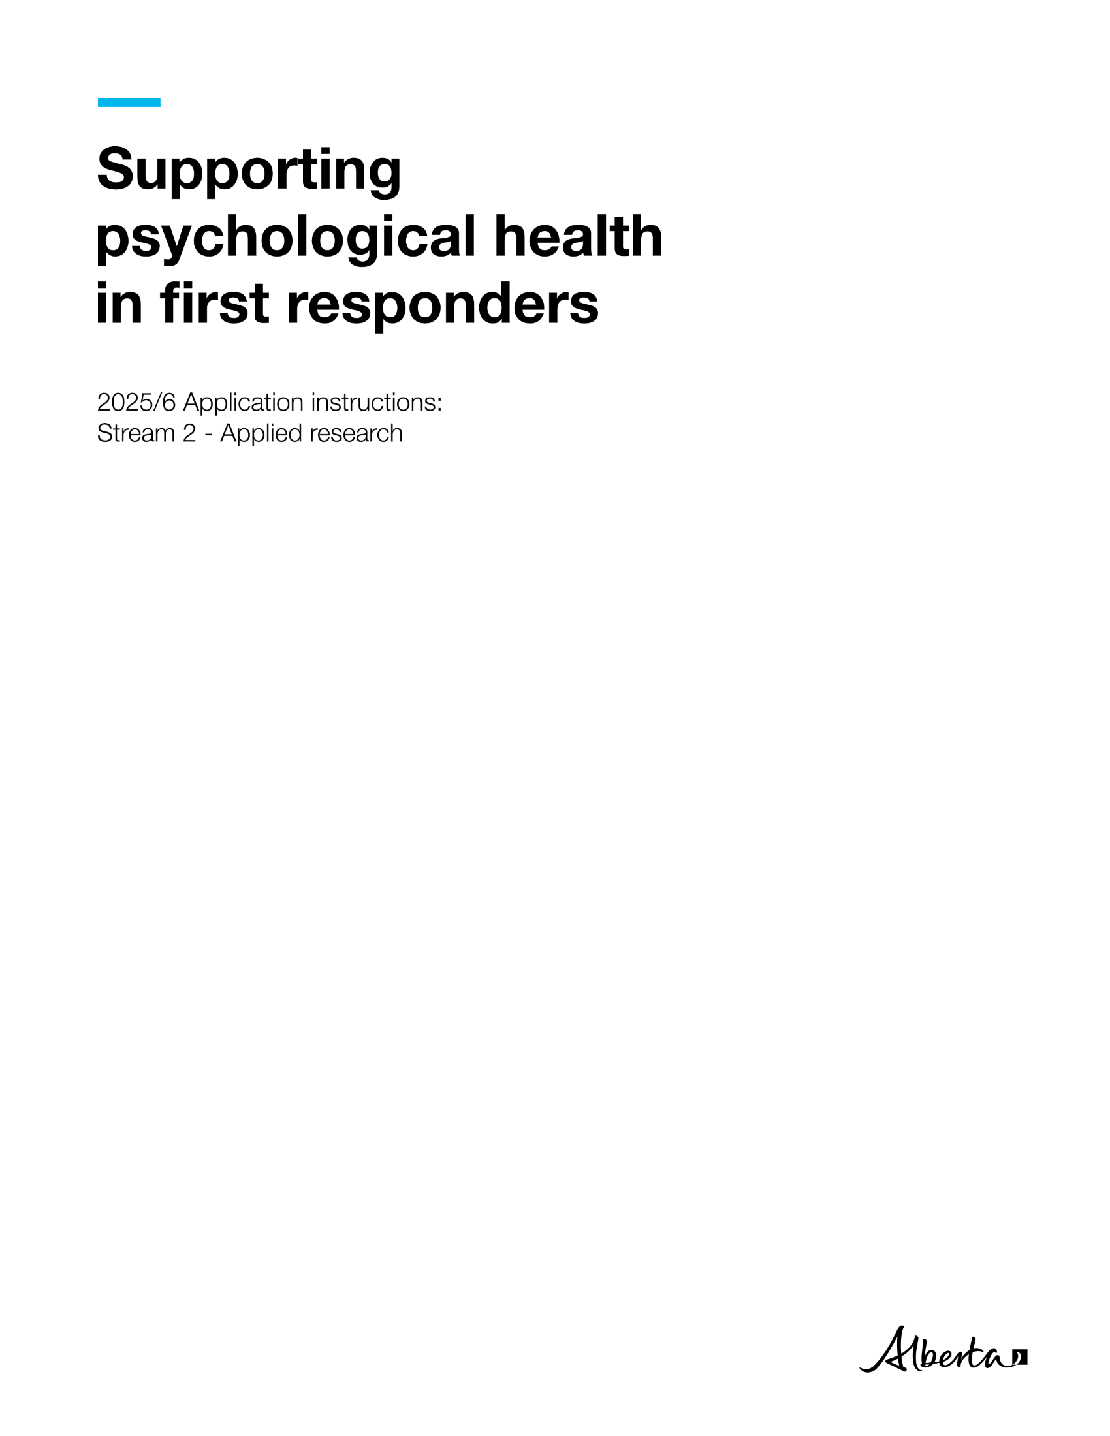



General information

The Supporting Psychological Health in First Responders (SPHIFR) grant program is a competitive grant funding program. It supplies funding to provide or improve services that support first responders or emergency workers living with or at risk for post-traumatic stress injuries (PTSI). For SPHIFR purposes, first responders and emergency workers are defined as workers who provide immediate assistance at emergency scenes. Emergencies are defined as serious, unexpected, and often dangerous situations requiring immediate action.

The application submission deadline is **May 26, 2025, at 11:59 p.m. MDT**. Only applications that are complete and are received before this deadline will be eligible for funding.

The SPHIFR grant program has two streams:

* **Stream 1 (Services)** provides project-based grants to not-for-profit or public sector organizations. These projects must provide services that support Alberta first responders or emergency workers living with, or who are at risk of, PTSI.
* **Stream 2 (Applied Research)** provides grants for applied research to develop and evaluate effective programs and services to support Alberta first responders or emergency workers living with, or who are at risk of, PTSI. Examples of such programs and services include early intervention or resilience-building.

**The eligibility criteria and instructions in this document are only for Stream 2 (Applied Research) applications.** If you want to apply for funding under Stream 1, see [Stream 1 (Services) eligibility criteria and instructions](https://ohs-pubstore.labour.alberta.ca/grt001) on Alberta’s OHS Resource Portal. If you have questions about which stream is the best fit for your project, contact [SPHIFR@gov.ab.ca](mailto:SPHIFR@gov.ab.ca).

Applicants can seek SPHIFR grant funding for multiple projects in a funding year. Each project must be distinct and independent. Applicants must submit a separate and standalone application for each project.

You can submit this application for funding to continue a project that received SPHIFR funding in the past. You can also submit this application if you are hoping to apply for funding in subsequent years (for the same project or a different project). However, it is important to note that receiving SPHIFR funding in any given year neither implies nor guarantees you will receive funding in this or any future year.

Jobs, Economy and Trade (“the Ministry”) will notify applicants about the outcome of their application in writing. Grant recipients will receive a grant agreement that will include the terms and conditions of the grant. Sample grant agreements for [public bodies](https://ohs-pubstore.labour.alberta.ca/grt002-1) and [non-public bodies](https://ohs-pubstore.labour.alberta.ca/grt002-2) are available online. Projects cannot start before both parties (the grant recipient and the Ministry) sign the grant agreement. Grant recipients must complete projects within 12 months of the date the grant agreement is signed by both parties.

Evaluation

The Ministry evaluates the information provided in each SPHIFR application individually. If applicable, the Ministry will also consider publicly available information (e.g., websites) and previous grant performance with the Ministry for both the applicant and co-applicants. The Ministry may not issue a grant to applicants who have not met the terms and conditions of previous Ministry grants.

If the applicant has identified a project partner, the Ministry may consider the partner’s publicly available information and previous grant performance with the Ministry.

Preference will be given to projects that incorporate considerations of sex, gender, sexual orientation, ethnicity, indigenous perspectives, geography, faith, income, gender identity and gender expression.

Stream 2 (Applied Research) eligibility criteria

|  |  |  |
| --- | --- | --- |
| **Criteria** | **Eligible** | **Not Eligible** |
| **Principal applicant** | **Must:**  Be affiliated with a Canadian-based organization.  Have the qualifications and appropriate expertise to conduct the proposed research.  Agree to provide data and reports outlined in the grant agreement. | **Must not:**  Be a full-time employee of a Government of Alberta ministry. |
| **Co-applicant**[1]**, if applicable** (see footnote for definition of co-applicant) | **Must:**  Make a significant contribution to the intellectual direction of the research or research-related activity.  Play a significant role in the conduct of the research or research-related activity.  **May have:**  Some responsibility for financial aspects of the research. | **Must not:**  Be a full-time employee of a Government of Alberta ministry. |
| **Proposed project** | **Must:**  Generate evidence on prevention or intervention for PTSI in first responders and/or emergency workers.  Be completed within 12 months. | **Must not be:**  A project that is required to be completed under law.  Drug trials.  A for-profit product development or endorsement.  Focused on general mental health or well-being without a clear focus on PTSI.  Directed towards a provincial or federal agency, board or commission as the primary participant/sole audience or the direct beneficiary of the project deliverables. |
| **Budget** | **Can fund:**  Salaries and benefits for trainees and support staff only.  Supplies that will be needed for the project.  Travel and subsistence costs directly related to and necessary to carry out the activities under the project. (Travel and subsistence costs must comply with the [Government of Alberta Travel, meal and hospitality expenses policy](https://open.alberta.ca/publications/travel-meal-and-hospitality-expenses-policy-expenses-policy).)  Knowledge transfer activities.  Permanent equipment needed for the project.  (**Note:** If the project is partially funded by another organization, the principal applicant must clearly indicate what components will be funded by SPHIFR, in order to avoid overlap.) | **Cannot fund:**  A project that is already in progress or has been completed.  Capital purchases.  The primary investigator/applicant’s salary or benefits.  Overhead, administrative costs, buyouts of teaching time, or other applicant responsibilities. |

How to fill out the application form

Begin your application by downloading and completing the [grant application form](https://cfr.forms.gov.ab.ca/Form/OHSP12387). The application form is a dynamic form; fields will appear or disappear depending on your selections.

As you fill out the form, you can click the **Save** button to save your progress, or the **Print** button if you would like to print out the form. Clicking the **Reset** button will reset the form and erase all data that has been entered thus far; be careful not to inadvertently click this button as you proceed through the form.

The application form’s fields will display word limits, which are also stated in the instructions below. The Ministry will not consider any information that exceeds a designated word limit.

The Ministry may quote portions of successful applications in public communications, including on the [SPHIFR grant program](https://www.alberta.ca/first-responders-mental-health-grants.aspx#jumplinks-5) website. Do not include confidential information in the form.

Use plain (non-technical) language in all sections *except* the **Research Methods** section. The application will be reviewed by non-technical reviewers in addition to subject matter experts. Using plain language will help demonstrate that you know how to present technical information for non-technical audiences.

Descriptions of the application form’s sections and fields, and the information that must be provided in them, are as follows:

SPHIFR stream selection

When you first open the grant [application form](https://cfr.forms.gov.ab.ca/Form/OHSP12387), you will need to select the stream for which you are applying: **Stream 1 (Services)** or **Stream 2 (Applied Research)**. The rest of the application form will appear, with fields based on the stream you selected.

Project title

Provide a short descriptive title for your project. The Ministry will use this title in future communications.

1. Principal Applicant Information

As principal applicant, you have primary responsibility for the research project and administrative responsibility for the grant. Provide your *work* contact information (not your home contact information) in this section.

You will receive all correspondence and notifications from the Ministry during the application review process and throughout the project (if successful). Notify [SPHIFR@gov.ab.ca](mailto:SPHIFR@gov.ab.ca) if your contact information changes after you submit the application.

If your application is successful, the Ministry will disburse the funds to the institution/organization identified in this section.

**Note**: You must include your résumé or CV (five pages maximum) with your application (see **Additional attachments** for instructions).

1. Do you have a Co-Applicant?

Co-applicants not only contribute to a project, but also have some shared (yet secondary) responsibility for project outcomes. The Ministry assesses co-applicant credentials as part of the application. Co-applicants must meet **eligibility criteria** set out in the table above.

If you have one or more co-applicants, select “Yes” in response to the “Do you have a co-applicant?” question. Provide their contact information and describe their expected level of involvement in the project (e.g. development of the research proposal, actual research work, knowledge transfer). If you have multiple co-applicants, add information for each separately by clicking the **(+) button** at the bottom right side of the field.

Provide a résumé or CV (five pages maximum) for each co-applicant. (See **Additional attachments** for instructions.)

1. Do you have a Collaborator or Partner?

SPHIFR defines **collaborators** and **partners** as follows:

**Collaborator**: An individual (other than the principal or a co-applicant) who will have a significant role in the conduct or intellectual direction of the project.

**Partner**: A partner must be an organization (i.e. not an individual), such as a post-secondary institution, a for-profit or not-for-profit organization, or a foundation. The partner is expected to:

* participate actively as part of a formal partnership;
* contribute in a meaningful way to the success of the project; and
* support the activities of the project by sharing intellectual leadership or providing expertise.

If you have one or more collaborators or partners, select “Yes” in response to the “Do you have a collaborator or partner?” question. Provide their contact information and describe their expected level of involvement in the project (e.g. development of the research proposal, actual research work, knowledge transfer).

Add additional collaborators or partners using the **(+) button** at the bottom right side of the field.

1. Research Services Office Contact Information

An institution’s research services office assists in managing research funding. Provide their contact information.

**Note**: It is recommended that you contact the office in advance to let them know you will be submitting this grant application.

Some institutions may have an office that is not referred to as a “research services office” but performs a similar function. If you are not sure what your institution’s equivalent office is, contact [SPHIFR@gov.ab.ca](mailto:SPHIFR@gov.ab.ca).

1. Project Information

Click the box next to the certificates that are required for your project. In the dropdown menu that appears, select whether the certificate is obtained, not yet applied for, or applied for but not yet obtained. If a required certificate is not listed, click the “Other” checkbox, then enter the certificate and select its status from the dropdown menu that appears.

Your affiliated institution should have this information.

## Abstract

Give a brief description of the proposed research using **plain (non-technical) language** that will be understandable by a wide audience. The Ministry may quote from the abstract in public communications about the project.   
**Word limit: 250**

## Research Questions

State the research question or questions. As with the abstract, use **plain (non-technical) language** that will be understandable by a wide audience. Research questions are another example of information that the Ministry may typically quote in public communications.   
**Word limit: 50**

## SPHIFR Priority Alignment

Explain how the proposed research will align with the goal of SPHIFR Stream 2, which is to provide grants for “applied research to develop and evaluate effective programs and services that support Alberta first responders or emergency workers living with, or who are at risk of, PTSI.”

Describe how research results will:

* impact Alberta first responders and/or emergency workers living with, or at risk of, PSTI; and/or
* inform policy and practices that will impact Alberta first responders and/or emergency workers living with, or at risk of, PSTI.

Cite evidence that supports a need for your project. You can use whichever citation style you prefer, but be consistent throughout this section and the rest of the application.

Submit a reference list (two-page maximum) with the application’s attachments (see **Additional attachments** for instructions on how to do this)  
**Word limit: 500**

## Research Methods

Provide a detailed description of the proposed research and evaluation design and methods. **Use technical language as needed.** Explain the rationale behind the selected methods. Include as applicable:

* data collection methods and tools;
* sampling frames;
* sample sizes;
* recruitment strategies;
* evaluation framework and tools (e.g. performance metrics, logic models);
* statistical analyses; and
* limitations.

If your project will use administrative data, indicate the data source. Explain how you will access the data. **Note**: Receipt of a SPHIFR grant does not guarantee access to Ministry data.

Provide any key tables, images, graphs, and cited references as additional attachments (see **Additional attachments** for instructions on how to do this).

The Ministry will use information you provide in this section to assess the scientific rigor of the project design and methods.  
**Word limit: 5,000**

## Explain how your project builds capacity within first responders, emergency workers, or their supports, to prevent PTSI or lessen the severity of PTSI in workers following traumatic incidents.

Provide details on how the project considers ways to prepare first responders or emergency workers for traumatic events or prepare front-line supervisors and family members to support workers who experience traumatic events, in order to ultimately prevent or lessen the severity of PTSI among workers.   
**Word limit: 30**

1. Risk assessment

Complete the fields in this section as follows:

* **Potential Risk Event**: Identify potential risks to specific project objectives, milestones, activities or deliverables.
* **Likelihood**: Select whether the potential risk is very likely, probable or very unlikely.
* **Impact**: Select whether the impact of the risk (if it were to occur) would be high, medium or low.
* **Mitigation Plan:** Describe the strategy or plan to mitigate or minimize the potential risk.

Examples of potential risks include lack of cooperation from workplace parties, inadequate participation of subjects, resource unavailability or delays that could impact the timelines.

**Example:**

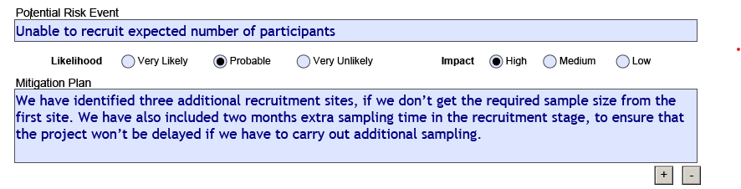

Use a separate row for each potential risk. You can add more rows using the **(+) button** at the bottom of the table.

1. Project Milestones, Timeframes and Deliverables

Use this table to describe the major milestones for the project and their associated timeframes. Milestones are tangible accomplishments that are significant to the project’s progress and success. Give timeframes in weeks or months relative to the start date of the project, not in absolute dates (e.g. “Week 5”, not “the first week of September”).

If your project has multiple research objectives, include milestones, timeframes and deliverables for each objective.

**Example:**

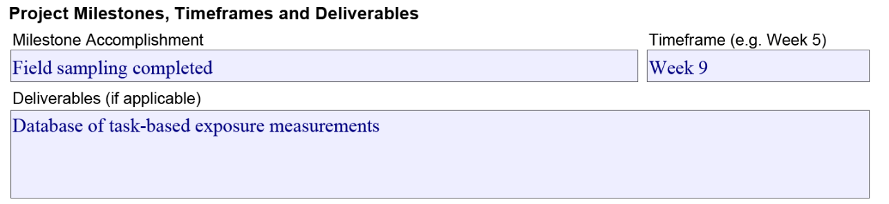

Use the **(+) button** at the bottom of the table to add additional milestones.

**Note**: Projects cannot start before both parties (the grant recipient and the Ministry) sign the grant agreement. Grant recipients must complete projects within 12 months of the date the grant agreement is signed.

1. Knowledge Transfer

## Audiences and End Users

Identify key academic and non-academic audiences, as well as potential end users of the research results.

If you mentioned collaboration with potential end users in the application, list them in this section. Describe how this project will transfer knowledge to Alberta workers/workplaces and the research community. (This knowledge transfer can happen during the research project or after it concludes.)  
**Word limit: 250**

## Tools and Methods

Describe the tools or methods you will use to involve or engage your audiences and end users. Some examples of tools include plain language summaries, infographics, posters or guidelines. Some examples of distribution methods include websites, newsletters, conferences or seminars, or social media.

Ensure that your planned tools and methods are reasonable, appropriate and feasible for your project. Consider factors such as your audiences/end users and expected research results.

Your planned tools and methods must fit within the 12-month grant timeline and be included in your budget.   
**Word limit: 250**

1. Budget

Provide information about the anticipated budget for your program by entering the description and amount of each budget item in the appropriate subsection, as well as the general details and rationale pertaining to each subsection’s budget. The budget items you provide should *only* occur within the 12-month grant timeline.

**Note**: Overhead, administrative costs, buyouts of teaching time or other applicant responsibilities are not eligible expenses.

Click the **(+) button** in any subsection if you need to add more rows

## Salaries and benefits

Enter salaries and benefits for trainees and support staff *only* (the primary investigator/applicant’s salary or benefits are not eligible expenses). If you need to fund salaries for support staff who have specialized expertise required for the success of the project (e.g. engineer, graphic designer, etc.), provide a justification in the Role and Responsibility of Individual(s) field.

If a salary/benefit is for someone who will be working outside Alberta, specify that in the Description field.

## Supplies

Enter information and estimated costs for any supplies that will be needed for the project.

## Travel

Enter information and estimated costs for any travel associated with the project. The sum of these travel costs cannot exceed **10% of the total budget** or **$5,000**, whichever is lower.

All planned travel must comply with the Government of Alberta’s [Travel, meal and hospitality expenses policy](https://open.alberta.ca/publications/travel-meal-and-hospitality-expenses-policy-expenses-policy).

## Knowledge Transfer

Enter information and estimated costs for knowledge transfer, which can include knowledge transfer activities either during or after the project. **Note**: Include any travel costs related to knowledge transfer (e.g. flights to attend conferences) in the **Travel** subsection (see above).

## Permanent Equipment (if applicable)

Enter information and estimated costs for any permanent equipment that will be needed for the project. The sum of these permanent equipment costs cannot exceed **10 per cent of the total budget** or **$5,000**, whichever is lower.

## Additional sources of funding

If you have applied for additional research funding related to this project, identify:

* the funding source;
* if the funding has been received or is pending review;
* who on the project team holds the funding; and
* the requested/received funding amount.

**Note:**

Non-public bodies that receive a grant between $100,000.01 and $250,000.00, must provide a **Review Engagement Report**:

* The Review Engagement Report must be prepared by a third-party Chartered Professional Accountant who is not associated with your organization.
* This report must have accompanying financial statements showing the grant income and expenditures (either as a separate statement or as a schedule attached to your organization’s overall unaudited financial statement) and the return of any unused funds, if applicable.
* The report must confirm that the funds were only used in accordance with the purpose of the grant.
* This report will be due 90 days after your organization’s fiscal year end.
* The cost of a Review Engagement Report must be included in your application budget.

Non-public bodies that receive a grant where the value is over $250,000.00, must provide an **Audited Financial Statement**:

* An Audited Financial Statement of your organization is required which is to include a schedule showing the grant income and expenditures and the return of unused grant funds, if applicable.
* This statement must be prepared by a Chartered Professional Accountant, and can be your organization’s Chartered Professional Accountant, if applicable.
* This statement must confirm that the funds were only used in accordance with the purpose of the grant.
* This statement will be due 90 days after your organization’s fiscal year end.
* The cost of an Audited Financial Statement must be included in your application budget.

10. Project signatories

The principal applicant and an institution representative identified by the research services office (e.g. financial officer, research services officer) must both sign the application. Make sure to contact your research services office to find out who the institution representative will be for this application. The Ministry will not accept unsigned applications.

You can sign your application in one of two ways (electronic signature is preferred):

**Use an electronic signature (*preferred*):**

1. Electronically sign the completed application PDF.
2. Click the **Submit** button. This will automatically create an email addressed to [SPHIFR@gov.ab.ca](mailto:SPHIFR@gov.ab.ca), with your signed, completed application PDF attached. **Do not remove this attached PDF file from the email.**
3. Manually attach any additional documents as needed (see **Application attachments** below).
4. Send the email.

**– OR –**

**Scan the signature page:**

1. Print, sign and date the signature page. Scan the signature page and save it as a PDF file.
2. Return to your application PDF and click the **Submit** button. This will automatically create an email addressed to [SPHIFR@gov.ab.ca](mailto:SPHIFR@gov.ab.ca), with the unsigned, completed application PDF file included as an attachment. **Do not remove this attached PDF file from the email.**
3. Manually attach the scanned signature page PDF that you created in step one to the email, as well as any additional documents as needed (see **Application attachments** below).
4. Send the email.

Application attachments

You must submit any applicable required documents with your application, attached to your application submission email.

* **Résumé or CV**: Include a résumé or CV for the principal applicant and any co-applicants. Each must be no more than five pages.
  + The Ministry will not review additional résumés or CVs other than those of the principal applicant and any co-applicants.
  + The Ministry will not consider any information after the fifth page of any submitted résumé or CV.
* **Reference list**: Provide any citations/references used in your application.
* **Supplemental documents**: If you referenced separate images, tables, graphs or letters of support in your application, include these as attachments. Clearly label each with a name that relates directly to the information you provided.

Confirmation of application receipt

After sending your application, you should receive an email from [SPHIFR@gov.ab.ca](mailto:SPHIFR@gov.ab.ca) within three business days confirming that your application was received. If you do not get the confirmation email, check your email software’s spam/junk folder. You may also want to ensure your organization’s network allows incoming emails from Government of Alberta email addresses. If you have done these steps but still have not received a confirmation email after three business days, contact [SPHIFR@gov.ab.ca](mailto:SPHIFR@gov.ab.ca).

Contact

If you have any questions about the application, contact [SPHIFR@gov.ab.ca](mailto:SPHIFR@gov.ab.ca).

1. Social Sciences and Humanities Research Council (SSHRC) Definitions of Terms: https://www.sshrc-crsh.gc.ca/funding-financement/programs-programmes/definitions-eng.aspx#a4