Fall protection plan template
This is one example of a fall protection plan template. If you choose to use this template, make sure you customize it to your work and work site.
Name of employer:
Work site (i.e. civic address):
Period for which this plan is valid:

Fall hazards at the work site
Identify the specific work area and circumstances where a worker could fall (e.g. “leading edge of second floor work area”, “unguarded opening on third floor”, etc.)
_____________________________________________________________________________________________
_____________________________________________________________________________________________
_____________________________________________________________________________________________
_____________________________________________________________________________________________
_____________________________________________________________________________________________

Fall protection system(s) to be used at the work site
Brief description of the system(s) being used (fall arrest, travel restraint, fall restrict, horizontal lifeline, safety net, work positioning, control zone, etc.)
_____________________________________________________________________________________________
_____________________________________________________________________________________________
_____________________________________________________________________________________________
_____________________________________________________________________________________________
_____________________________________________________________________________________________

Anchor(s) to be used
Locations of permanent and improvised (if used) anchors, any special requirements such as connecting hardware, type, thickness, and condition of material to which the anchor is connected to ensure minimum required strength, etc. The employer should ensure the site has adequate anchor points to minimize the possibility of a worker experiencing a swing fall.
_____________________________________________________________________________________________
_____________________________________________________________________________________________
_____________________________________________________________________________________________
_____________________________________________________________________________________________
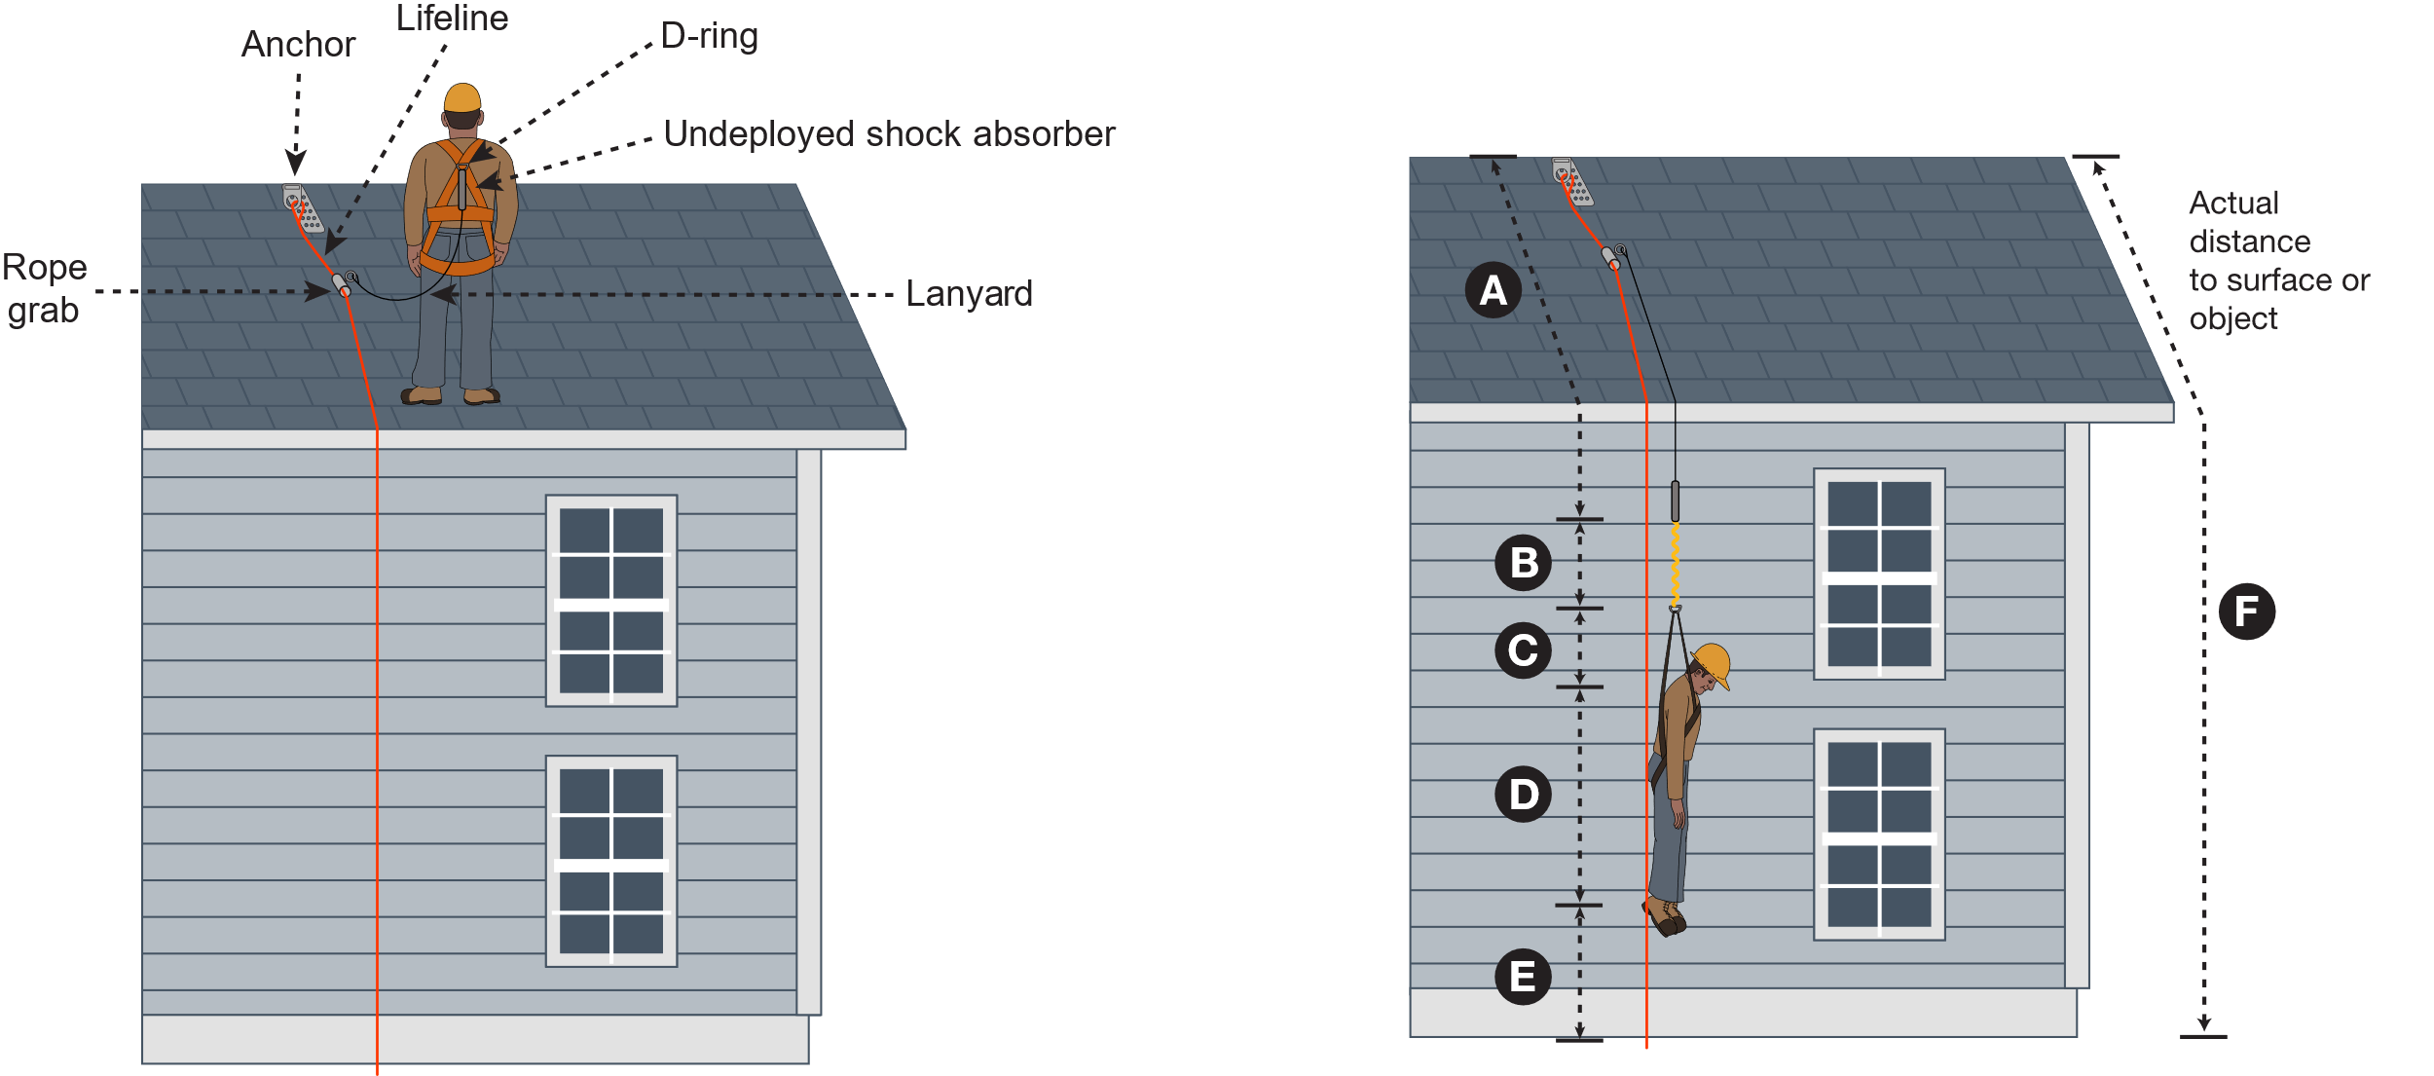
Clearance requirement
This must be calculated (you can use the worksheet below for convenience). The distance the worker falls must be less than the distance to the ground or an object or level below the work area (such as a balcony, mezzanine, or HVAC ducting).

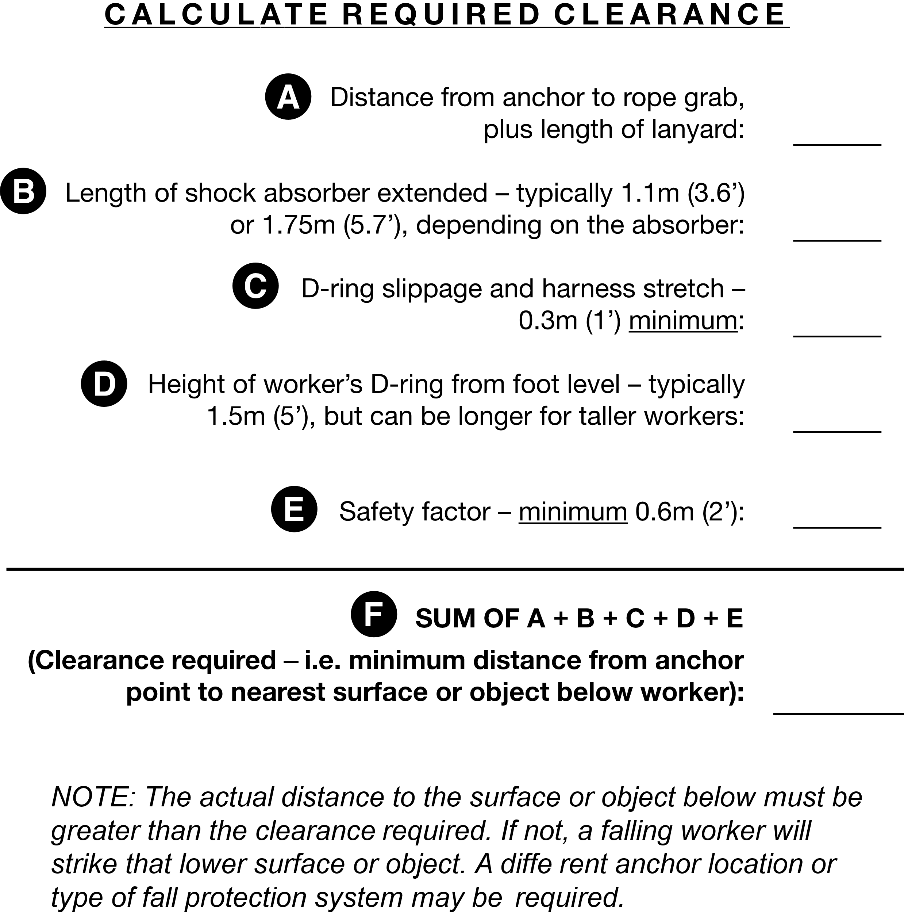
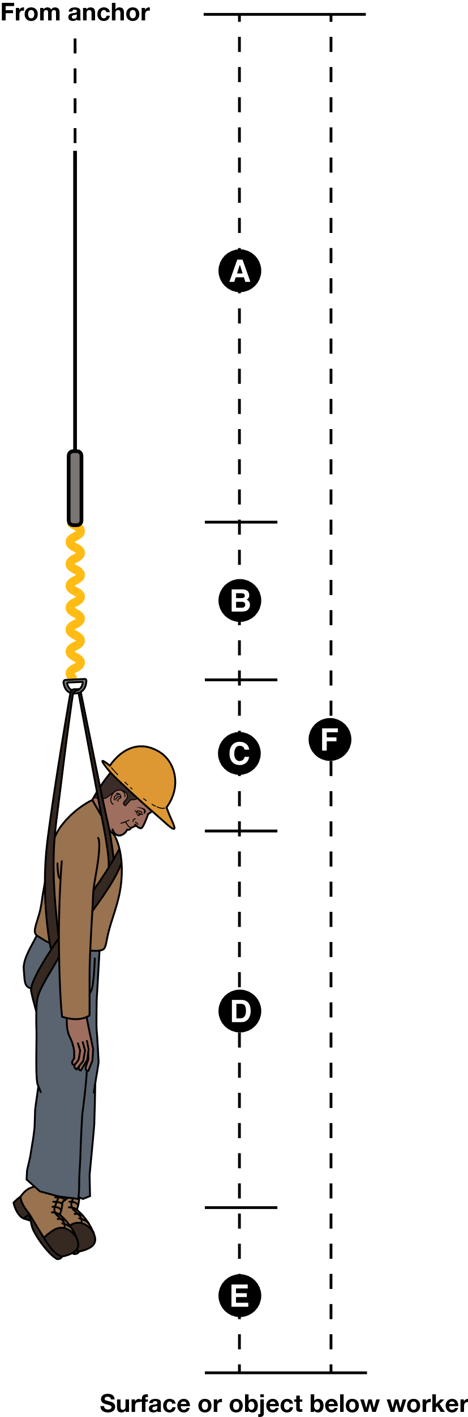
Procedures to assemble, maintain, inspect, use and disassemble the fall protection system
Procedures for simple systems can be listed here. For complex systems, it is acceptable to reference procedures that appear elsewhere as a separate document. The procedures must be readily available for reference at the work site. This can mean a paper copy of the instructions on site or an electronic copy that is downloaded to a tablet, laptop, or smartphone. The information must be retrievable without an internet connection so that the person needing it has access to it at all times.
_____________________________________________________________________________________________
_____________________________________________________________________________________________
_____________________________________________________________________________________________
_____________________________________________________________________________________________
_____________________________________________________________________________________________
_____________________________________________________________________________________________
_____________________________________________________________________________________________

Rescue procedures
List the rescue procedures that are in place to quickly return a worker to safety if the worker is left suspended as a result of a fall.
_____________________________________________________________________________________________
_____________________________________________________________________________________________
_____________________________________________________________________________________________
_____________________________________________________________________________________________
_____________________________________________________________________________________________
_____________________________________________________________________________________________

Worker sign-off
The employer must ensure all workers affected by this fall protection plan have reviewed it. As an example of a way to fulfil that requirement, this template asks workers to sign off on the plan. However, employers are free to determine the best way to fulfil this requirement at their particular work site.
Worker Name: ___________________________________ Signature: ___________________________________
Worker Name: ___________________________________ Signature: ___________________________________
Worker Name: ___________________________________ Signature: ___________________________________
Worker Name: ___________________________________ Signature: ___________________________________
This template is for example purposes only. Completing this template alone will not necessarily put you in compliance with legislation. It is important and necessary that you customize this document to meet the unique circumstances of your work site. Further, it is essential that this document is not only completed, but is used, communicated, and implemented in accordance with the legislation. Neither the Crown, nor its agents, employees, or contractors, will be liable to you for any damages, direct or indirect, arising out of your use of this template.

